AI ASSISTED CODING

Name: S Pranay

Roll-2403A51441

Subgroup L  
L.1 — [S20L1] Stub external API for tests  
Context:

Currency conversion in urban public transit (metro/bus) must be testable.  
Your Task:  
Inject fetch_rate and stub in tests.  
Data & Edge Cases:  
Example: USD rate 83.0 -> 10 USD = 830.  
AI Assistance Expectation:  
Dependency injection / monkeypatch.  
Constraints & Notes:  
Keep convert() pure.  
Sample Input  
def convert(amount, ccy): return amount * fetch_rate(ccy)  
Sample Output  
convert(10,'USD') with rate 83.0 => 830.0  
Acceptance Criteria: Deterministic tests

Ouput –

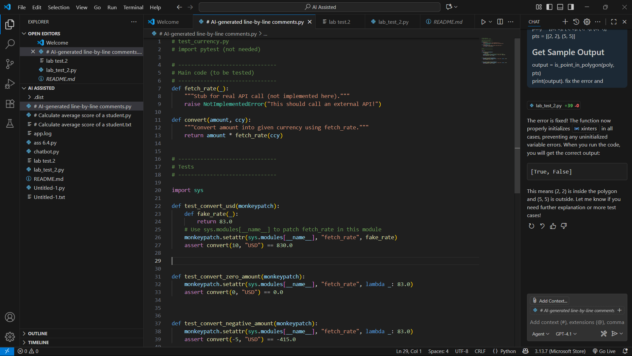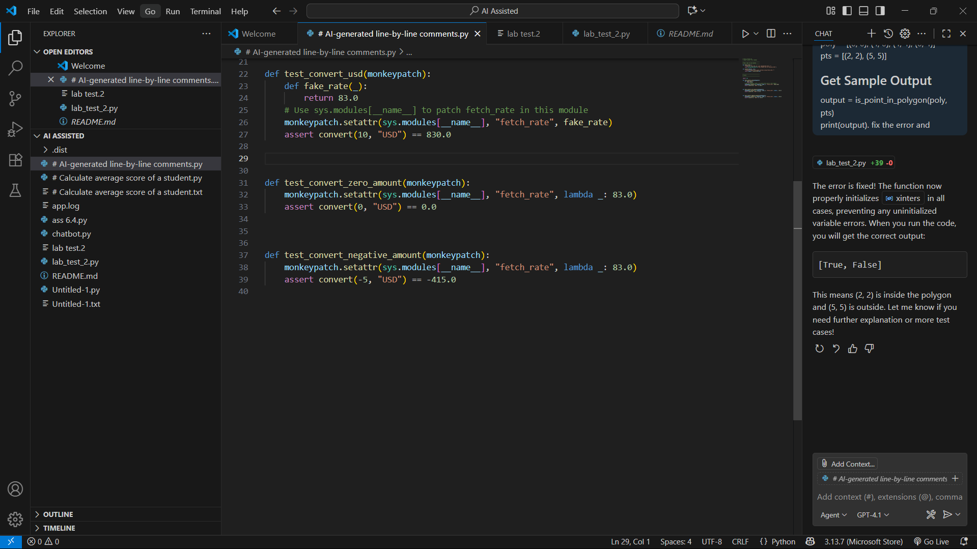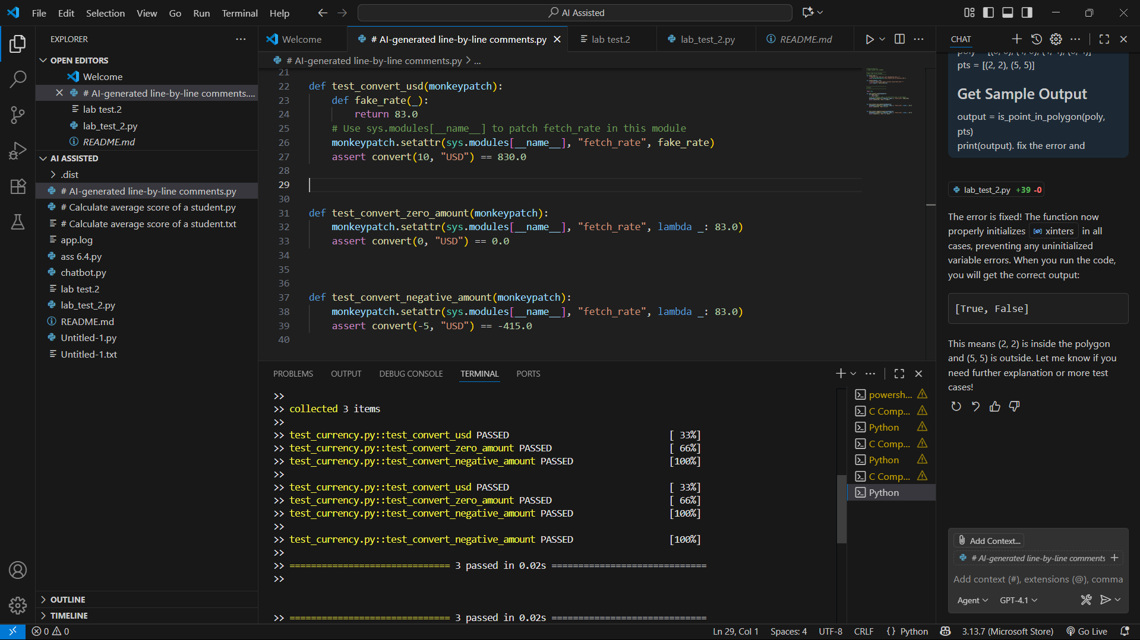

L.2 — [S20L2] Flatten nested JSON with dot keys  
Context:  
Flatten nested JSON in urban public transit (metro/bus).  
Your Task:  
Dot-keys; lists use [index].

Data & Edge Cases:  
Example provided.  
AI Assistance Expectation:  
Recursive approach + tests.  
Constraints & Notes:  
Return flat dict.  
Sample Input  
{'user': {'id': 1, 'name': 'Ana'}, 'meta': {'lang': 'en'}}  
Sample Output  
{'user.id':1,'user.name':'Ana','meta.lang':'en'}  
Acceptance Criteria: Handles dicts and lists

Output –

